Press Release March 2018

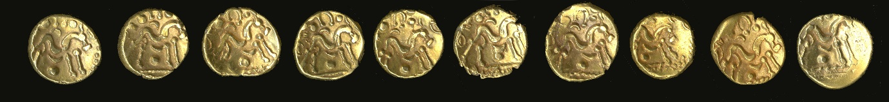
Image courtesy The British Museum Trust
Exciting and Important Discovery to join displays at Local Museum
A rare hoard of 10 gold coins recently discovered in Chiddingstone is being acquired by the Eden Valley Museum in Edenbridge.
Official Opening: Saturday 7th April 2018,
1pm. Press Call. See the Chiddingstone Hoard. Meet Jonathan Barber the finder, and the Museum team who worked to secure the Chiddingstone Hoard for the Eden Valley.
2.30. Talk ‘The Chiddingstone Hoard, Treasure and Portable Antiquities in Kent’ by Jo Ahmet, the Kent Finds Liaison Officer and an opportunity to meet Jonathan Barber, the finder of the Chiddingstone Hoard. £6 (Members £5)
Open to the public Wednesday 11th April 2018.
Claire Donithorn BA, resident archaeologist at the museum said, "These will be our first significant Iron Age exhibits. They date from precisely the time when Britain emerged from Prehistoric to Historic Times. Our aim now is to keep the hoard together and to ensure that it stays in the Valley for us and for future generations.”
Experts in the British Museum examined the coins and identified them. The Eden Valley Museum was then offered the chance to buy them. The Museum leapt at the opportunity. Claire Donithorn said, “These coins are an important part of the history of the Eden Valley. They show that the Valley was connected to great events in European History – the Gallic Wars. Whoever buried them may have been involved in those wars and was probably living here in the Valley."
The coins date from the Late Iron Age, about the time of Caesar’s invasions of Britain. They were manufactured in the region of Amiens in Northern France and are thought to be of a type struck by the local tribes to finance their resistance to the invading Romans.
At this time both South East England and France were occupied by Celtic tribes who were closely connected by trade and family alliances. Celts from England fought with the Celts in France. It is likely that the coins found their way back to Kent as the pay or booty of soldiers. Then, for reasons we can only guess at, they were buried and remained in the ground for over two thousand years until a metal detectorist discovered them.
Fundraising Campaign
The Museum is launching a fund raising campaign to raise money to cover the costs of the purchase of the coins and of setting up a new display area in which to house them. Our target is £13,000.
Grant Funding
The museum has secured grant funding of £11,315 from South East Museums Development Programme, Arts Council England/V&A Museum Purchase Grant Fund* and the Headley Trust towards the costs of this project.
Local Support
To encourage local support for this campaign, badges at £1 each will be available together with the opportunity to help finance the project through cash and online donations. There will also be a programme of talks and events taking place in 2018.
Schools & Education
Our gold coins will be on permanent display in the Museum for children to see from 11 April 2018. Pupils studying the Iron Age at Key Stage 1 and 2 can discover how our coins were minted, find out how the design of the coins developed and consider why the obverse side of the coins are blank. Our coin hoard, which was found in Chiddingstone, can support local history study within the National Curriculum.
Images:
Attached photographs may be used. Please acknowledge 'Courtesy of the British Museum'. Badge logo: ©EVMT
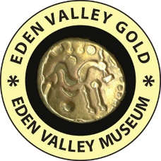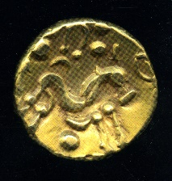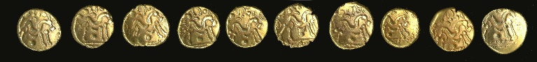
Contacts:

For further information please contact the museum or visit our website.
Miranda Charalambous, Collections Coordinator
Claire Donithorn, Resident Archaeologist
Paul Byrne, House Manager
Eden Valley Museum, 72 High Street, Edenbridge, TN8 7LE
01732 864653
curator@evmt.org.uk
Further Notes:
The coins are Gallo-Belgic staters dating from between c60 to c50 BC. They were struck by the Ambiani Tribe in what is now Northern France. The reverse of the coins shows a stylised horse whilst the obverse is blank. It is thought that the obverse, which would normally show the head of the local ruler, was left blank precisely because the coins were minted by an alliance of Gallic tribes uniting to fight Julius Caesar.
Caesar invaded Gaul in 58 BC and after several years of fighting effectively conquered Gaul by 51 BC. During this time he made his two incursions into Britain landing, it is now thought, at Pegwell Bay in 55 and 54 BC. All these campaigns were chronicled by Caesar in his “Gallic Wars”.
Precious goods appear to have been often buried by Prehistoric peoples in Britain. It is suggested that they were buried as offerings to gods, perhaps to seal some important event. Alternatively it could be that they were simply hidden for safety.
 Supported by the South East Development Program ‘Ready to Borrow’ scheme. www.southeastmuseums.org
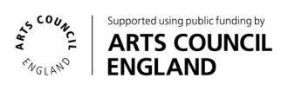
Supported using public funding by Arts Council England

*Arts Council England/Victoria and Albert Museum Purchase Grant Fund
- The Arts Council England/Victoria and Albert Museum Purchase Grant Fund is a government fund that helps regional museums, records offices and specialist libraries in England and Wales to acquire objects relating to the arts, literature and history.
- It was established at the Victoria and Albert Museum (V&A) in 1881 and continues to be part of its nationwide work.
- The annual grant budget, currently £750,000, is provided by Arts Council England (ACE).
- Each year, the Purchase Grant Fund considers some 200 applications and awards grants to around 100 organisations, enabling acquisitions of £3 million to go ahead.
Visit the website: www.vam.ac.uk/purchasegrantfund

Supported by the Headley Fund. www.hedleyfoundation.org.uk

