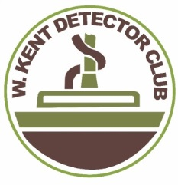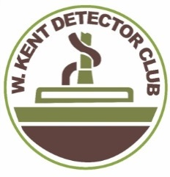
West Kent
Detector Club

Member of: the Kent Archaeological and Detectorist Liaison Group; Landscape Explorers Group in the Southeast;
National Council for Metal detecting (Southern Region); affiliated to Kent Archaeological Society.

TITLE……..MR/MRS/MISS/MS. NAME……………………………………………………………………………..

ADDRESS………………………………………………………………………………………………………………

…………………………………………………………………POSTCODE………………………………………….

TEL No…………………………………………………………..email…………………………………………………

Do you have transport?.............................Any detecting experience?..............................................................

Details of any previous or present detecting clubs………………………………………………………………….

…………………………………………………………………………………………………………………………….

Have you ever been refused admission or excluded from a club?....................................................................

Are you a member of the NCMD?............................. NCMD No. ………………………….

Any other hobbies or interests………………………………………………………………………………………..

DECLARATION: I hereby apply for membership of the West Kent Detector Club. If elected I agree to
comply with club rules. I understand that my membership may be terminated if I do not comply. I have no
objection to my personal details, as shown above, being kept on a computer database.

SIGNED…………………………………………. DATE……………………………………

FOR INFORMATION ONLY: Annual subscriptions: Full member: £20.00. Children under 16 £8.00. Family membership: first member: £20.00. additional members receive 20% discount. Associate membership: £8.00.
NCMD insurance (required) £8.00.

Please forward this application with two passport style photographs to:
WKDC, Membership Secretary, Robert Phillpot, 49 Lower Road, Orpington, Kent BR5 4AH
Tel: 07769 657802 email:robertphillpot41@hotmail.com

