Summary Definition of Treasure
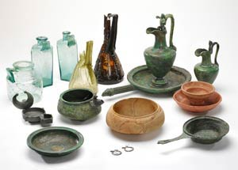The following finds are Treasure under the Act, if found after 24 September 1997 (or, in the case of category 2, if found after 1 January 2003):
- Any metallic object, other than a coin, provided that at least 10 per cent by weight of metal is precious metal (that is, gold or silver) and that it is at least 300 years old when found. If the object is of prehistoric date it will be Treasure provided any part of it is precious metal.
- Any group of two or more metallic objects of any composition of prehistoric date that come from the same find (see below)
- Two or more coins from the same find provided they are at least 300 years old when found and contain 10 per cent gold or silver (if the coins contain less than 10 per cent of gold or silver there must be at least ten of them). Only the following groups of coins will normally be regarded as coming from the same find: Hoards that have been deliberately hidden; Smaller groups of coins, such as the contents of purses, that may been dropped or lost; Votive or ritual deposits.
- Any object, whatever it is made of, that is found in the same place as, or had previously been together with, another object that is Treasure.
Any object that would previously have been treasure trove, but does not fall within the specific categories given above. Only objects that are less than 300 years old, that are made substantially of gold or silver, that have been deliberately hidden with the intention of recovery and whose owners or heirs are unknown will come into this category.
Note: An object or coin is part of the 'same find' as another object or coin if it is found in the same place as, or had previously been together with, the other object. Finds may have become scattered since they were originally deposited in the ground.

What should I do if I find something that may be Treasure?
You must report all finds of Treasure to a coroner for the district in which they are found either within 14 days after the day on which you made the discovery or within 14 days after the day on which you realised the find might be treasure. Your local Finds Liaison Officer can assist you in determining whether a find constitutes potential Treasure and can report the find to the coroner on your behalf.

